

**Dharmsinh Desai University, Nadiad**

Faculty of Technology

Department of Computer Engineering

B. Tech CE Semester – VI

Subject: System Design Practice

Project Title:

**TripManager**

**(Location Based Service)**

By:

1. Rutvik Kathrecha

CE-058

17CEUBS048

2) Priyanka Dave

CE-023

17ICUOG024

Guided by: Prof. Jigar M. Pandya



**Dharmsinh Desai University, Nadiad**

Faculty of Technology

Department of Computer Engineering

**CERTIFICATE**

This is to certify that the System Design Practice project entitled **“TripManager (Location Based Services)”** is a bona fide report of the work carried out by

1. **Rutvik Kathrecha, Roll No: CE058, Student ID No: 17CEUBS048**
2. **Priyanka Dave, Roll No: CE023, Student ID No: 17ICUOG024**

Of Department of Computer Engineering, Semester VI, academic year 2019-20, under the guidance and supervision for the subject System Design Practice.

(Project Guide) (HOD)

**Prof. Jigar M. Pandya Dr. C. K. Bhensdadia**

Assistant Professor Head of Department

Department of Computer Department of Computer

Engineering, Engineering,

Faculty of Technology, Faculty of Technology,

Dharmsinh Desai University, Dharmsinh Desai University,

Nadiad Nadiad

Contents

Introduction 1

Software Requirement Specifications 2

Design 6

Implementation Detail 18

Testing 20

Screen-shots 25

Conclusion 30

Limitation and Future Extension 31

Bibliography 32

# Abstract

Now a days everyone wants some quick finding of places or events where they can spend their spare time. The main thing is that in this busy world people don’t have much time so they want to visit places or events that are nearby and which take less time to explore but gives much amount of enjoyment. So, the solution is TripManager, the web application which we have developed. People can come and visit our website for information they want for nearby events.

# Introduction

The objective of the project is to develop a web application which provide information regarding nearby places and events. This objective much need to be satisfied in this world and current situation. People don’t have much time to invest and they want some quick findings which are nearby where they can spend their leisure time.

So, people can visit our website for the nearby information and can spend their time in nearby place or event. People can view nearby events. They can also sort events based on nearby distance like 5km, 10km, etc. They can also register for the event in which they want to go. For registering in the event user has to login in the website. If they don’t have an account they can sign up and then use the features of our website. People can also add their own events into the website. For this they have to provide necessary details for the event like name, price, capacity, address, etc. These users are also known as event organizers. They can also download the file which has details of people who have registered for the event. Event organizers can also update or delete their events.

**Technology used:**

* Cascading Style Sheet (CSS) for styling the HTML pages.
* Bootstrap 4 for developing responsive, mobile-first pages.
* JavaScript and jQuery for providing dynamic content for the HTML pages.
* AJAX for checking error conditions asynchronously
* Python as the programming language.
* Django for web development.
* MySQL for database access.
* Google Maps API for rendering and displaying Google Maps

**Platform used:**

* Sublime, Visual Studio Code – Text editor
* Django Administrator – for Admin site
* Umlet – for UML diagrams
* Google Cloud Console – for managing API key
* GitHub – for version control

# Software Requirement Specifications

**System Functional Requirements**

**R.1 User**

**R.1.1 Login**

Description: If you already have an account, login here.

Input: Username, password.

Output: Successfully logged in.

Processing: User will enter username and password to login, if already registered.

**R.1.2 Register**

Description: If you are a new user, register yourself. Registration requires personal details and a confirmation email will be sent after successful registration.

Input: Username, full name, email, password, contact number.

Output: Successfully registered.

Processing: User will enter personal details, if not registered.

**R.1.3 Search Events**

Description: Customer can search events based on location.

Input: distance, user selection.

Output: all the nearby events based on distance selected.

Processing: through longitude and latitude system can find out the exact location of the particular user and finds events nearby that location.

**R.1.4 Register for an Event**

Description: User can register for any active nearby events.

Input: name, email, contact number.

Output: Details are stored and redirected to payments page.

**R.1.5 Make payment**

Description: Customer can make payment through different methods.

**R.1.5.1 Make payment via Credit card/Debit card**

Input: User selection.

Output: Registration confirmed.

Processing: Amount will transfer from Customer's account to Manager's account.

**R.1.5.2 Make payment via UPI**

Input: User selection.

Output: Registration confirmed.

Processing: Amount will transfer from Customer's account to Manager's account.

**R.1.6 Manage Events**

Description: User can view all events, add new events and can update or cancel the events which they own.

**R.1.6.1 View Events**

Input: User selection

Output: Display all the events.

**R.1.6.2 Add Event**

Description: User can add new events in two steps which are as under.

**R.1.6.2.1 Add Event Details**

Input: Event details like event name, organizer, price, capacity, etc.

Output: Event details are stored and redirected to next form.

**R.1.6.2.2 Select Place**

Input: Enter the place address and select place from the suggestions.

Output: Event successfully registered.

**R.1.6.3 Update Event**

Input: Event details to be update.

Output: Event successfully updated.

**R.1.6.4 Cancel Event**

Input: User selection.

Output: Event successfully cancelled.

**R.1.7 Update Profile**

Description: User can update his/her personal details.

Input: Details to be update

Output: Profile updated successfully

**R.1.8 Download Registration List**

Description: Event organizer (user) can download the list of registered users in his/her event.

Input: User selection.

Output: File with registration list will be downloaded in csv format.

**R.1.9 Give Feedback**

Description: user can give the feedback either good or bad.

Input: User selection.

Output: Display feedback.

**R.1.10 View offers**

Description: User can view the offers.

Input: User selection.

Output: Display offers.

**R.1.11 Logout**

Description: User will logout from the application.

Input: User selection.

Output: Successfully logged out.

**R.2 Admin**

**R.2.1 Login**

Description: Admin can login in the system to perform actions.

Input: Username, password.

Output: Successfully logged in.

Processing: Admin will enter username and password to login, if already registered.

**R.2.2 View feedback**

Description: Admin can view feedbacks submitted by users.

Input: User selection.

Output: Display feedback.

**R.2.3 Manage Users**

Description: Admin can perform all the CRUD operation on users.

**R.2.4.1 View Users**

Input: User selection

Output: Display User details.

**R.2.4.2 Add User**

Input: User details.

Output: User successfully added.

**R.2.4.3 Update User**

Input: User details.

Output: User successfully updated.

**R.2.4.4 Remove User**

Input: User details.

Output: User successfully removed.

**R.2.4 Manage Events**

Description: Admin can perform all the CRUD operation on events.

**R.1.7.1 View Events**

Input: User selection

Output: Display event details.

**R.1.7.2 Add Event**

Input: Event details.

Output: Event successfully added.

**R.1.7.3 Update Event**

Input: Event details.

Output: Event successfully updated.

**R.1.7.4 Delete Event**

Input: Event details.

Output: Event successfully deleted.

**R.2.5 Logout**

Description: Admin will logout from the system.

Input: User selection.

Output: Successfully logged out.

**Other Non-Functional Requirements**

1. **Performance**

Performance of the system must be interactive and the delay involved must be less. So, in every action-response of the system, there are no immediate delays. In case of opening App component, or popping error messages and saving the settings then there will be delay of some seconds.

1. **Safety**

User details should be securely stored to the server. The main security concern is for account hence proper login mechanism should require.

1. **Reliability**

As the system provide the right tools for discussion, Problem solving it must be made sure that system is reliable.

1. **Database**

System requires to access user’s data fast to maintain the performance.

# Design

1. 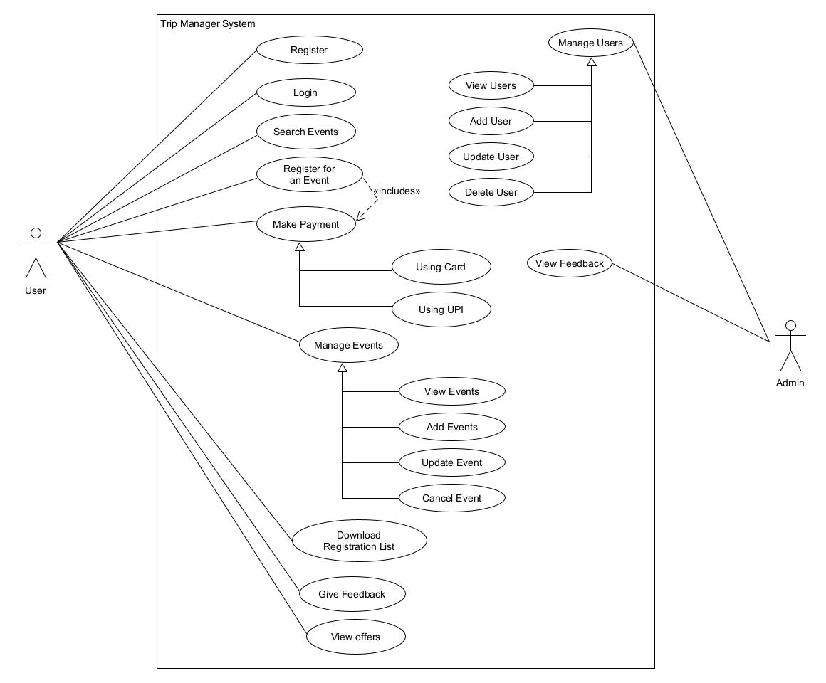Use Case Diagram
2. 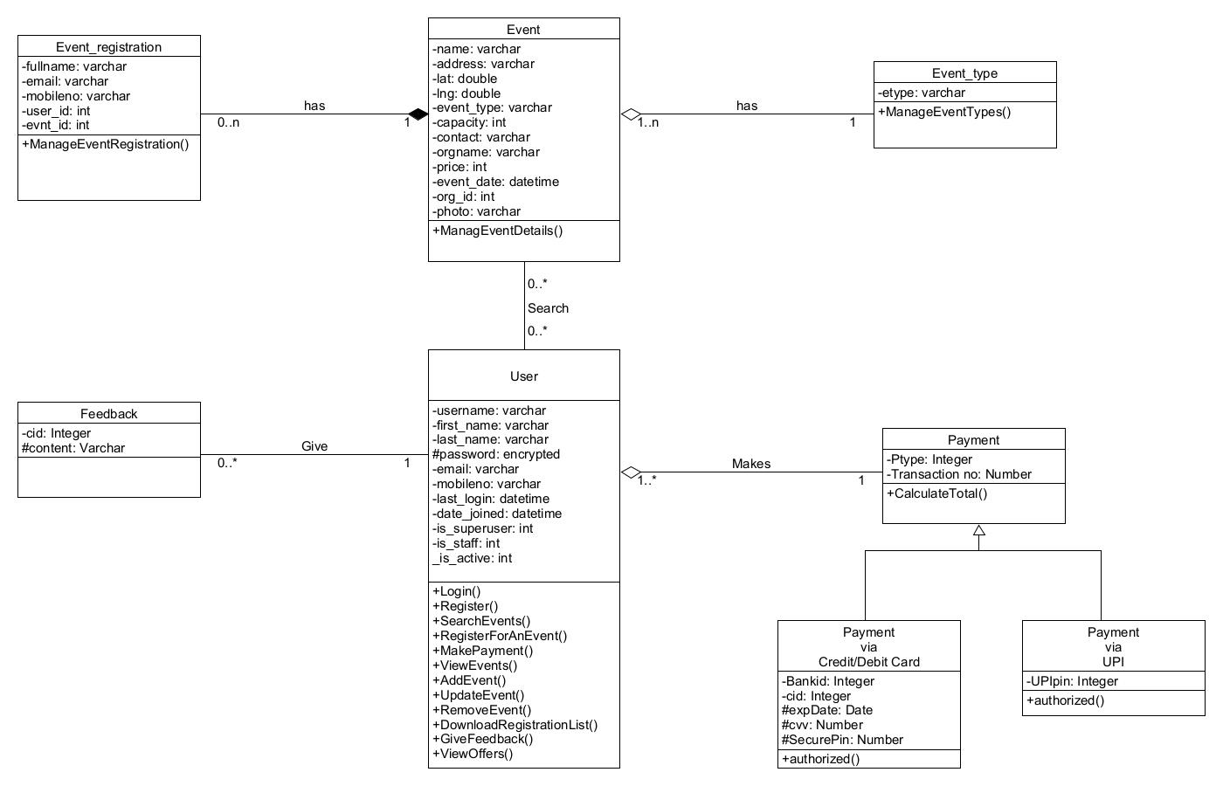Class Diagram
3. Sequence Diagram
4. 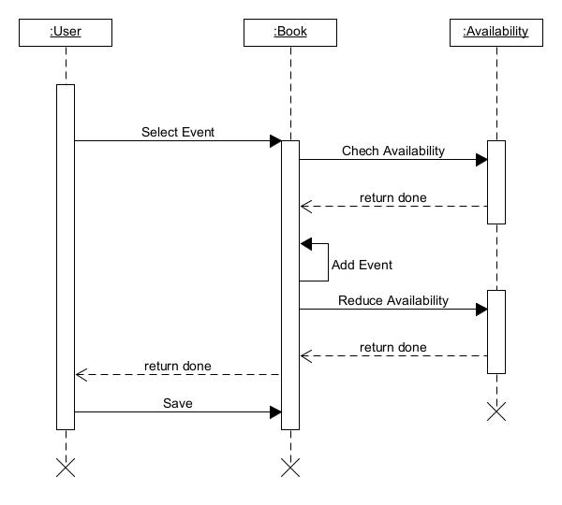Sequence diagram for registering for an event
5. 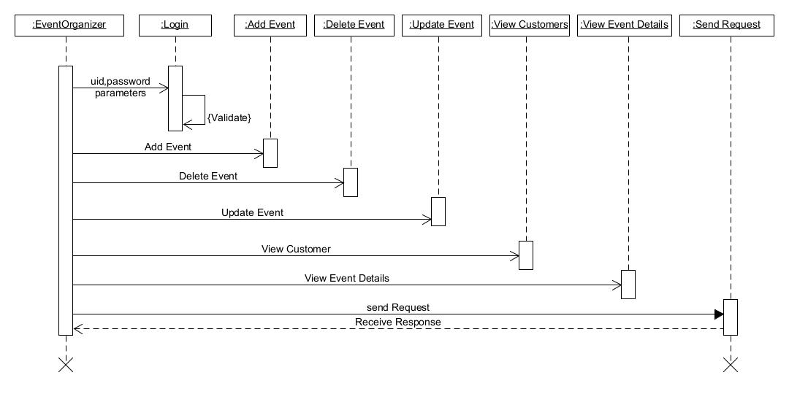Sequence diagram for Event Management by User

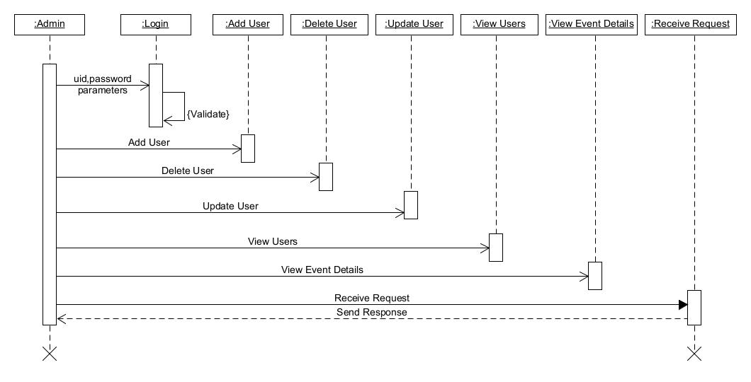c) Sequence diagram for User Management by Admin

1. Activity Diagram
2. 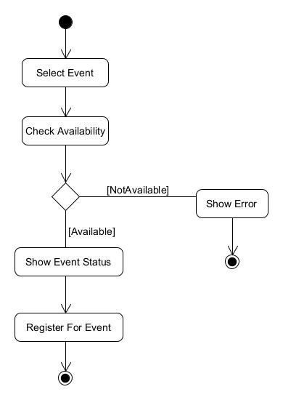Activity diagram for event registration
3. Activity diagram for event management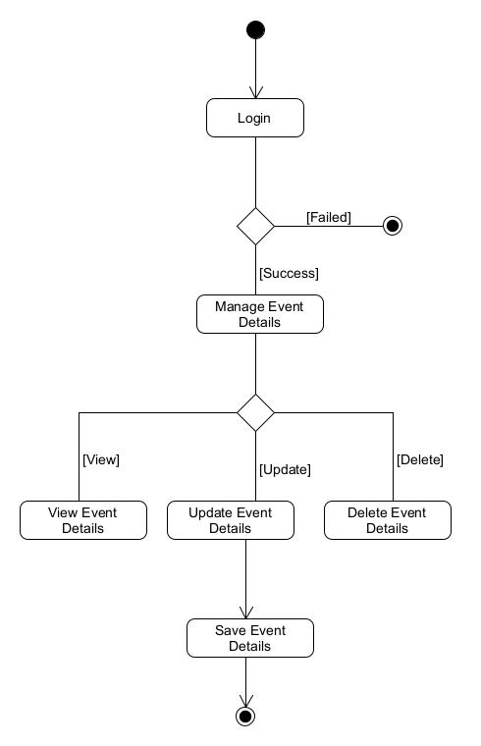
4. 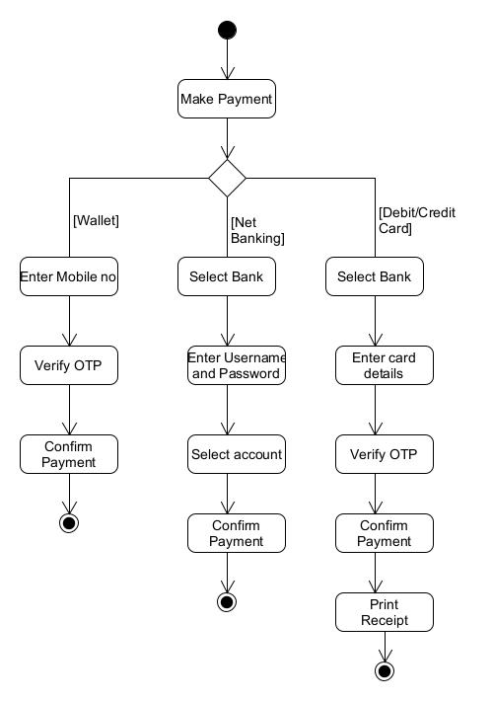Activity diagram for make payment
5. State Diagram

State diagram for event seat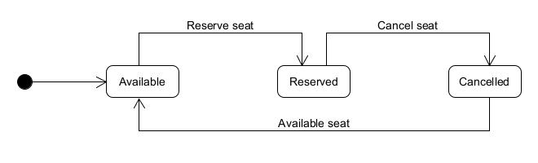

1. E-R Diagram

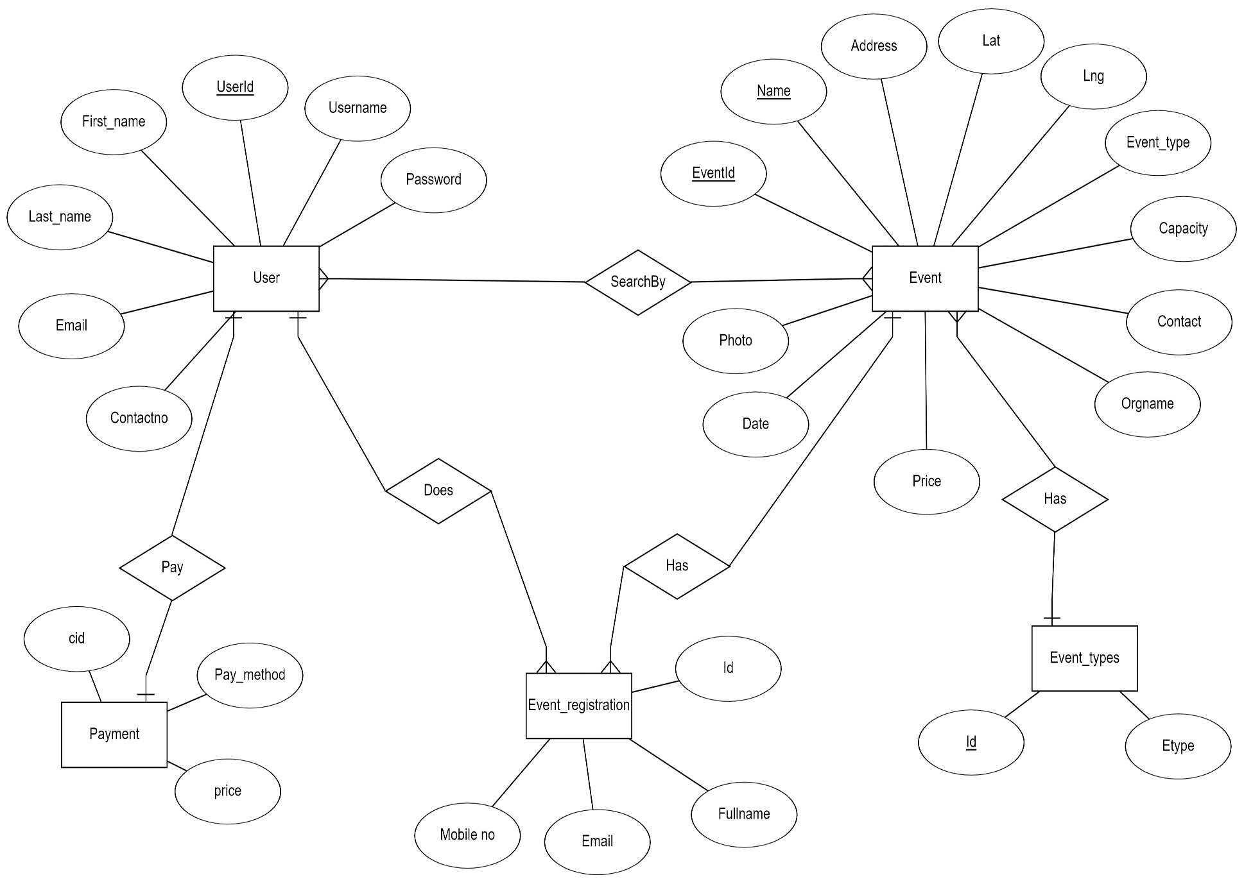

1. Data Dictionary

|  |  |  |  |  |  |  |  |  |
| --- | --- | --- | --- | --- | --- | --- | --- | --- |
| **Users** | | | | | | | | |
| **Sr no** | **Field name** | **Data type** | **Width** | **Required** | **Unique** | **PK/FK** | **Referenced table** | **Description** |
| 1 | Id | Number | 20 | Yes | Yes | PK |  | Primary Key for the user table |
| 2 | Password | Varchar2 | 10 | Yes |  |  |  | Password of the user |
| 3 | Last_login | Datetime | 10 |  |  |  |  | Last login time of the user |
| 4 | Is_superuser | Number | 1 |  |  |  |  | Is user superuser or not |
| 5 | Username | Varchar2 | 50 | Yes | Yes |  |  | Username of the user |
| 6 | First_name | Varchar2 | 30 | Yes |  |  |  | First name of the user |
| 7 | Last_name | Varchar2 | 10 | Yes |  |  |  | Last name of the user |
| 8 | Email | Varchar2 | 40 | Yes | Yes |  |  | Email ID of the user |
| 9 | Is_staff | Number | 1 |  |  |  |  | Is user staff member or not |
| 10 | Is_active | Number | 1 |  |  |  |  | Is user active or not |
| 11 | Date_joined | Datetime | 10 |  |  |  |  | Joining date of user in the system |
| 12 | Mobile no | Number | 10 | Yes | Yes |  |  | Mobile no. of the user |

|  |  |  |  |  |  |  |  |  |
| --- | --- | --- | --- | --- | --- | --- | --- | --- |
| **Events** | | | | | | | | |
| **Sr no** | **Field name** | **Data type** | **Width** | **Required** | **Unique** | **PK/FK** | **Referenced table** | **Description** |
| 1 | Id | Number | 20 | Yes | Yes | PK |  | Primary Key for the event table |
| 2 | Name | Varchar2 | 30 | Yes | Yes |  |  | Name of the event |
| 3 | Address | Varchar2 | 100 | Yes |  |  |  | Address of the event |
| 4 | Lat | Double | 20 | Yes |  |  |  | Latitude of the address |
| 5 | Lng | Double | 20 | Yes |  |  |  | Longitude of the address |
| 6 | Event_type | Varchar2 | 20 | Yes |  |  |  | Type of the event |
| 7 | Capacity | Number | 10 | Yes |  |  |  | Capacity of the persons in the event |
| 8 | Contact | Number | 10 | Yes |  |  |  | Contact no of the event organizer |
| 9 | Orgname | Varchar2 | 50 | Yes |  |  |  | Name of the organizing group or person |
| 10 | Price | Number | 10 | Yes |  |  |  | Price of the event |
| 11 | Date | Datetime | 10 | Yes |  |  |  | Date and time of the event |
| 12 | Org_Id | Number | 20 | Yes |  | FK | Users table | User id of the person who has registered the event |
| 13 | Photo | Varchar2 | 100 | No |  |  |  | Display Picture of the event |

|  |  |  |  |  |  |  |  |  |
| --- | --- | --- | --- | --- | --- | --- | --- | --- |
| **Event_types** | | | | | | | | |
| **Sr no** | **Field name** | **Data type** | **Width** | **Required** | **Unique** | **PK/FK** | **Referenced table** | **Description** |
| 1 | Id | Number | 20 | Yes | Yes | PK |  | Primary Key for the event types table |
| 2 | etype | Varchar2 | 50 | Yes | Yes |  |  | Type of the event |

|  |  |  |  |  |  |  |  |  |
| --- | --- | --- | --- | --- | --- | --- | --- | --- |
| **Event_registration** | | | | | | | | |
| **Sr no** | **Field name** | **Data type** | **Width** | **Required** | **Unique** | **PK/FK** | **Referenced table** | **Description** |
| 1 | Id | Number | 20 | Yes | Yes | PK |  | Primary Key for the event registration table |
| 2 | Fullname | Varchar2 | 100 | Yes | Yes |  |  | Name of the person |
| 3 | Email | Varchar2 | 40 | Yes | Yes |  |  | Email ID of the person |
| 4 | Mobile no | Number | 10 | Yes | Yes |  |  | Mobile no. of the person |
| 5 | Usr_id | Number | 20 | Yes |  | FK | Users table | User id of the person who has registered in the event |
| 6 | Event_id | Number | 20 | Yes | Yes | FK | Events table | Event id of the event in which user has registered |

# Implementation Detail

Home Module:

In the home page when user first time arrives events will be shown as per the default location. After user clicks the search nearby button, the website asks to give location access. If user agrees then all the events will be shown which are nearby to the user’s location. User can view the event details by clicking on any of the event. If user doesn’t allow location access then events will be shown as per the default location.

Login/Signup Module:

In signup module user can register themselves by providing details like name, email, password and mobile no. User will be validated at time of registration that it is previously exist or not and the details provided by them is valid or not. After successful registration user will also get a welcome email by the system. After registering themselves user can login into the system by providing email and password. Also, At the time of login user will be validated.

Event Registration Module:

User can register for any event only once. For event registration user have to go to the event details page and click on the register button. User have to provide details like name, email, and mobile no. After successfully registered for the event user will be notify by an email containing event details, for which user has registered.

Event Organizer Module:

Any user in the system can become Event Organizer and can register their own events in the system. For registering own event, user/event-organizer have to provide details related to event like event name, price, capacity etc. After submitting the details user will be redirected to submit address of the place using Google Maps. In which user has to write the address and pickup the place from the given suggestions. So, it will provide easy of access for event organizers. After successfully adding event in the system, event will be shown to other users based on the location of the event. Event organizer can also see the list of people who have registered in his/her event. Event organizer can also download the list in the csv (Excel) format. Event organizers can also update the event details, but they can’t update event name because of constraints. Event organizer can delete the events. Once deleted event will not be recovered anyhow.

Profile Module:

In the profile page user can view or edit their details. User can also view the events which they own or for which they have registered. User can view event details by clicking on the event name.

# Testing

1. Login

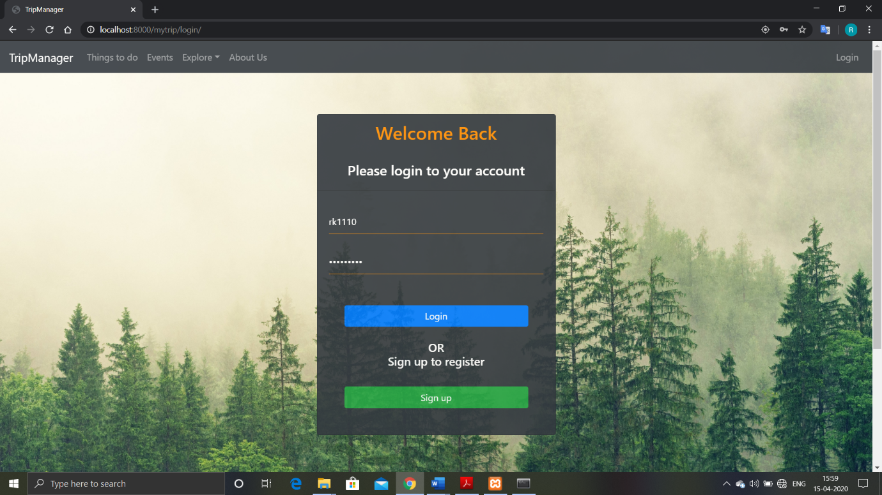Below is the snapshot of login module.

If the details are incorrect than below message will be shown as pop-up.

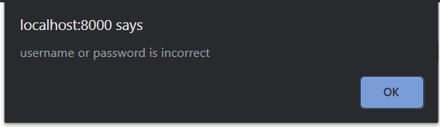

1. Signup

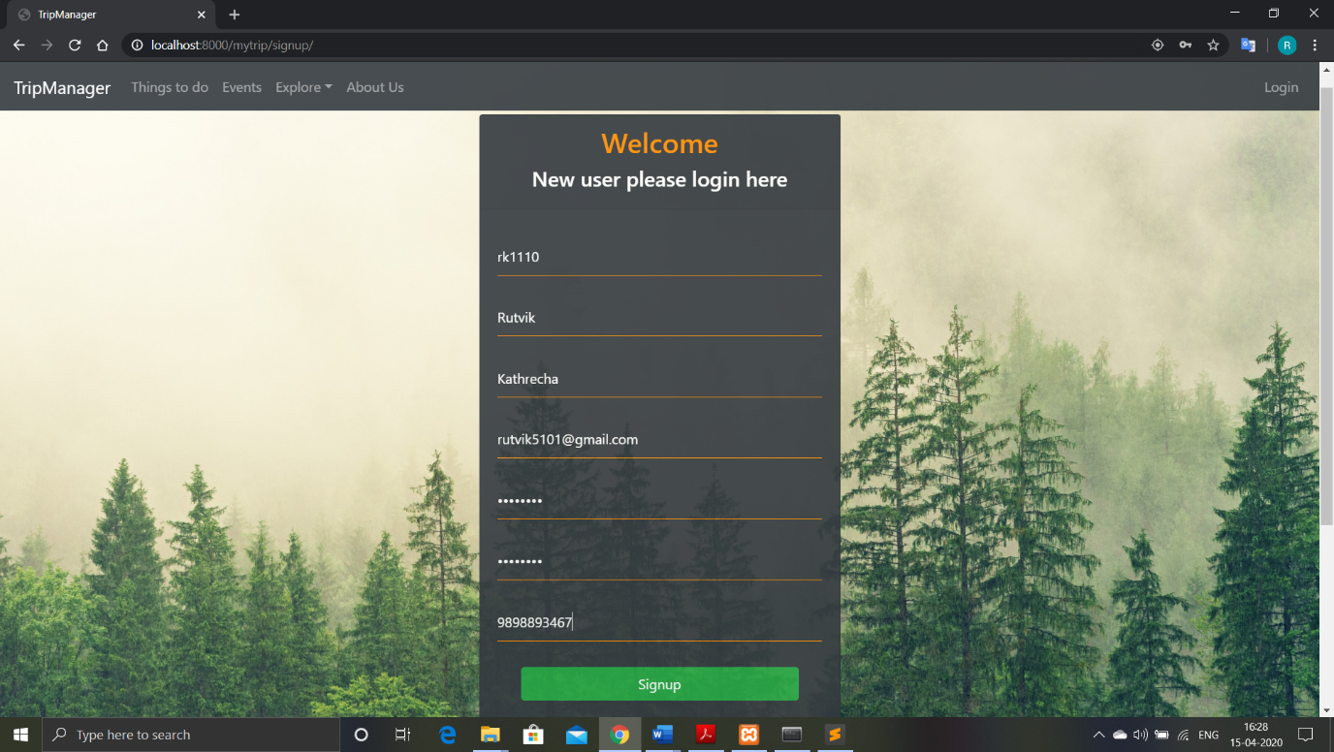Below is the snapshot of the signup module.

Different test cases will execute based on the different scenarios and appropriate messages will be shown.

* 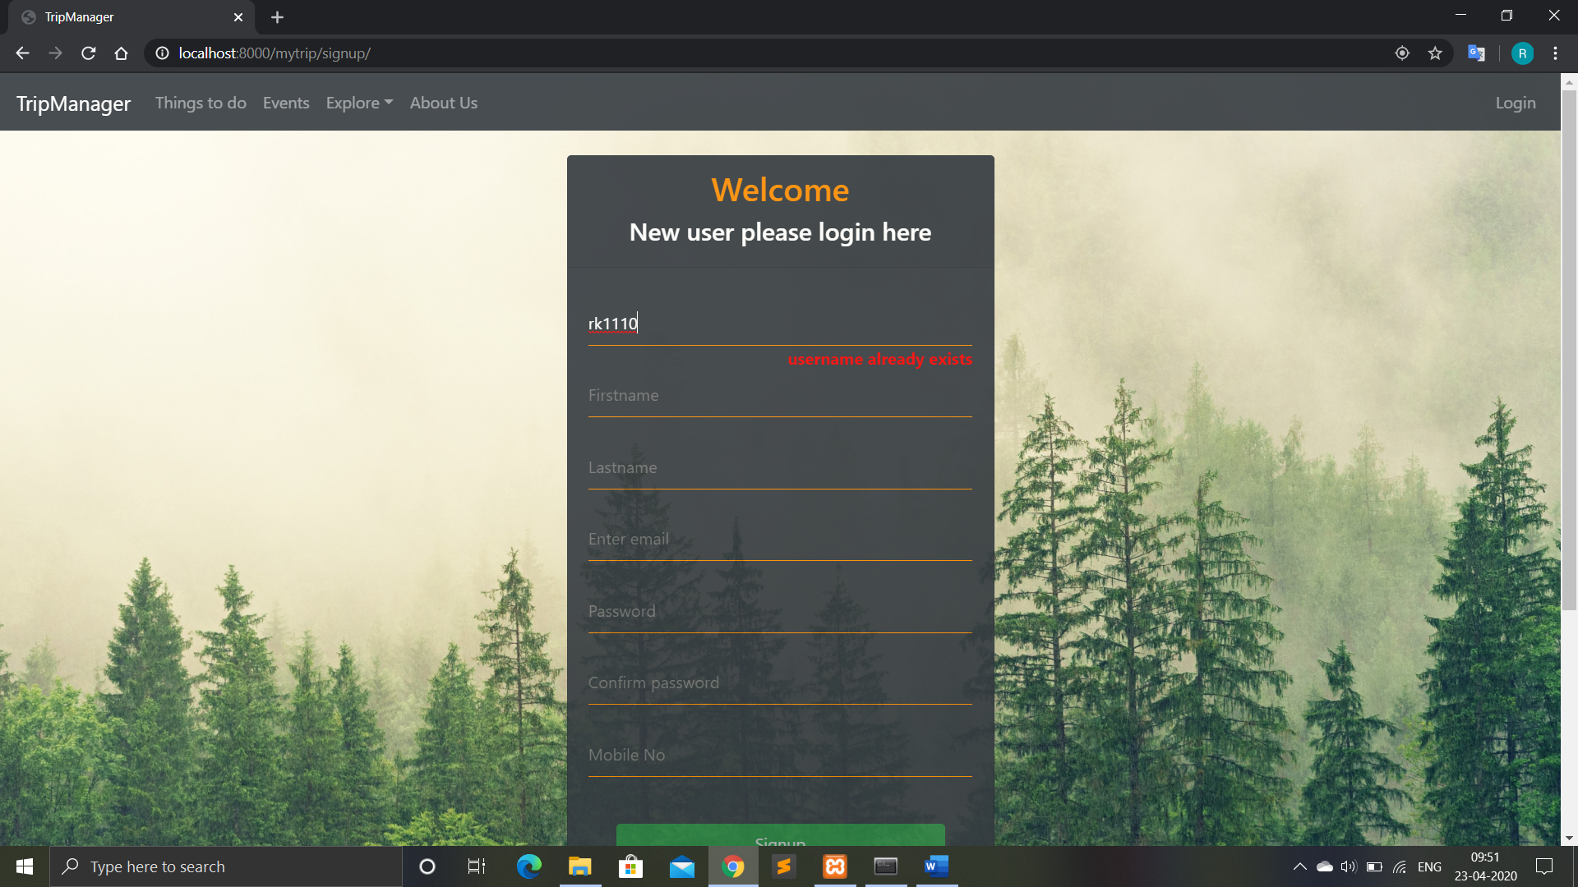When username already in use
* When email already in use

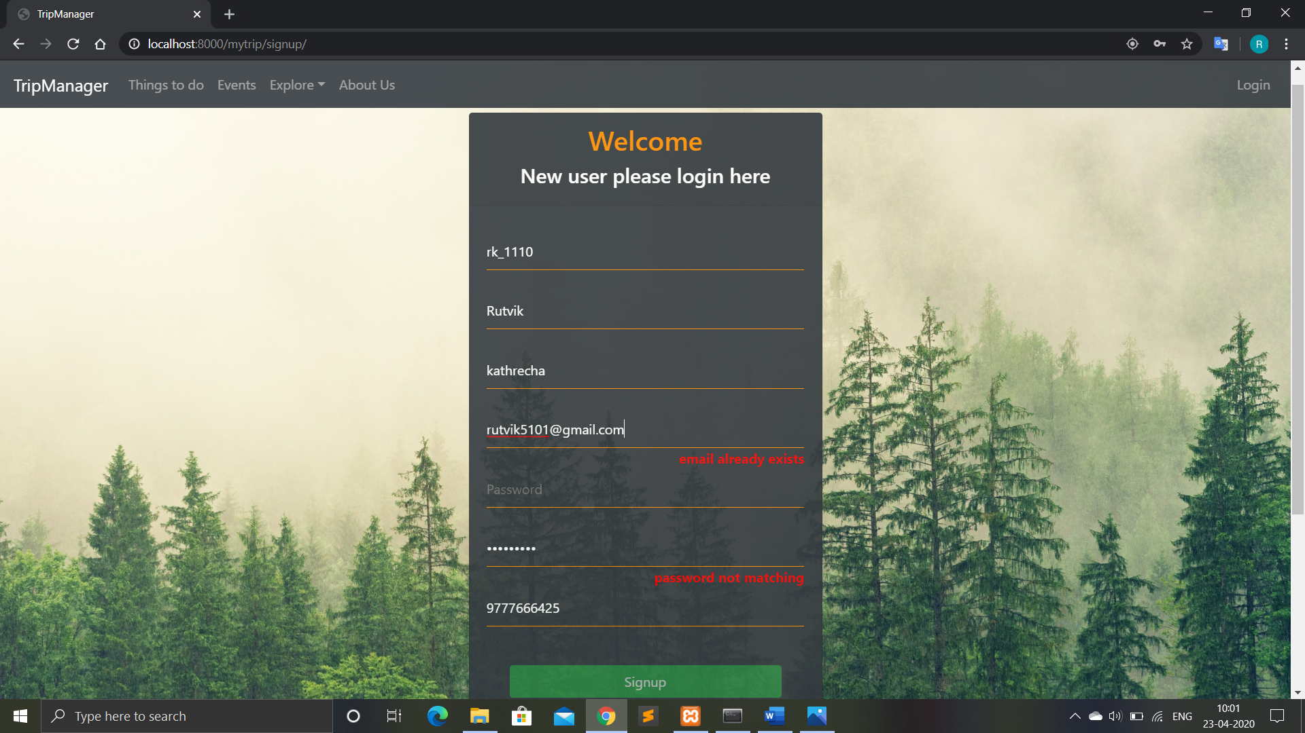

* When password and confirm password are not same

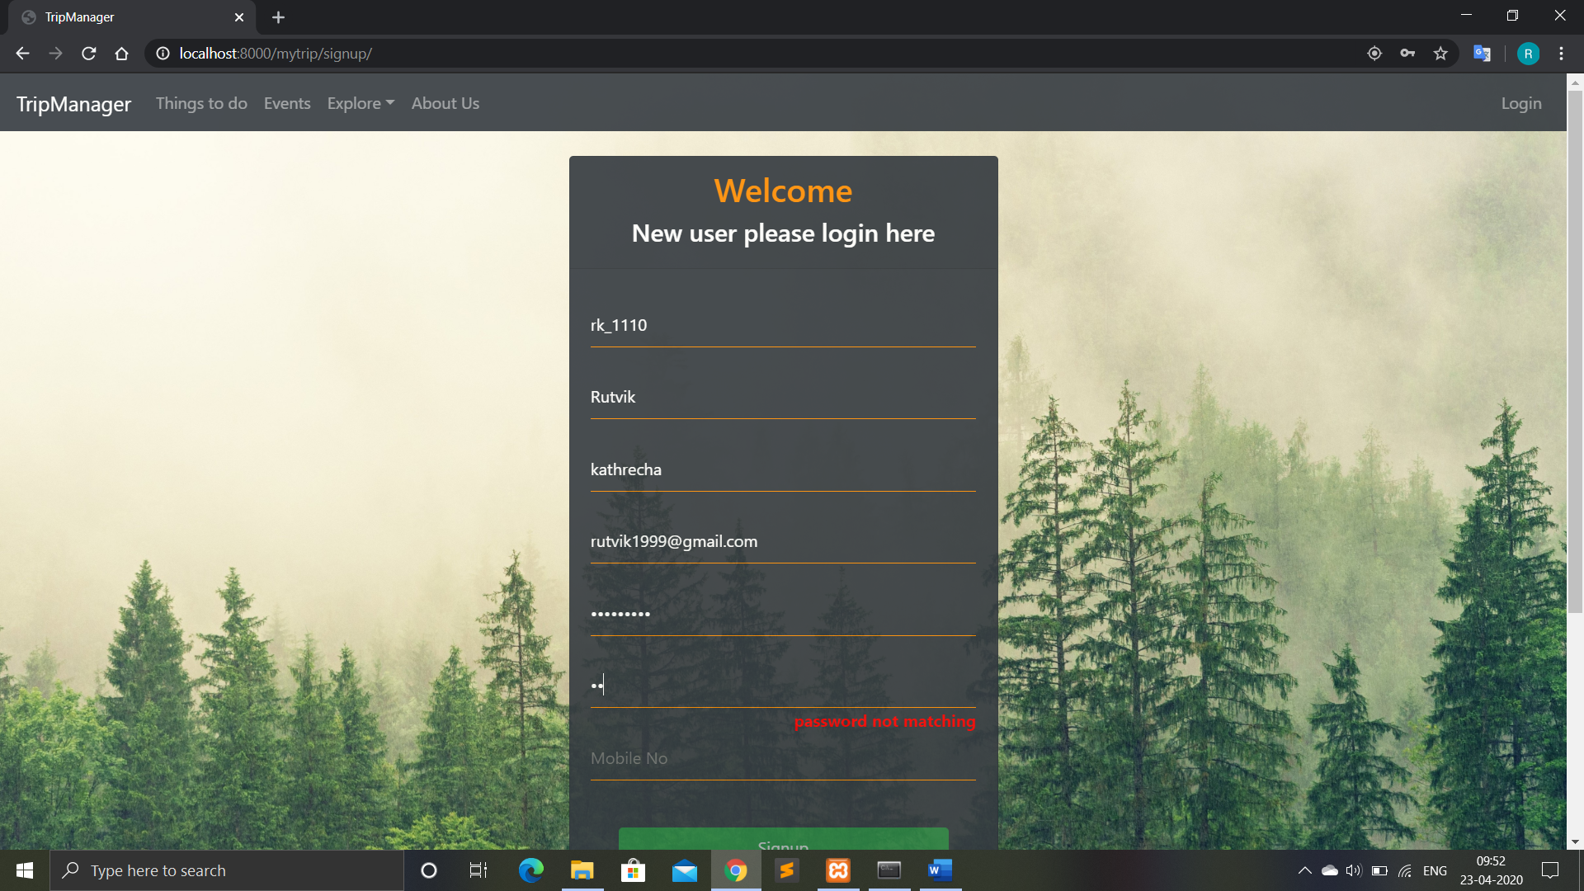

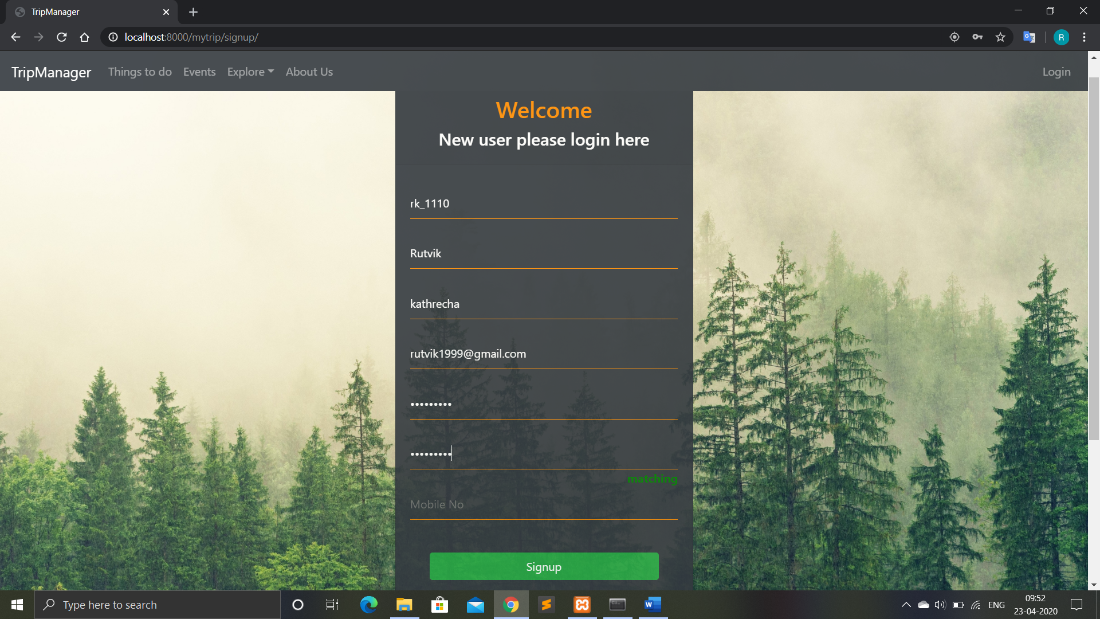After both passwords are same

* When mobile no is not of 10 digits

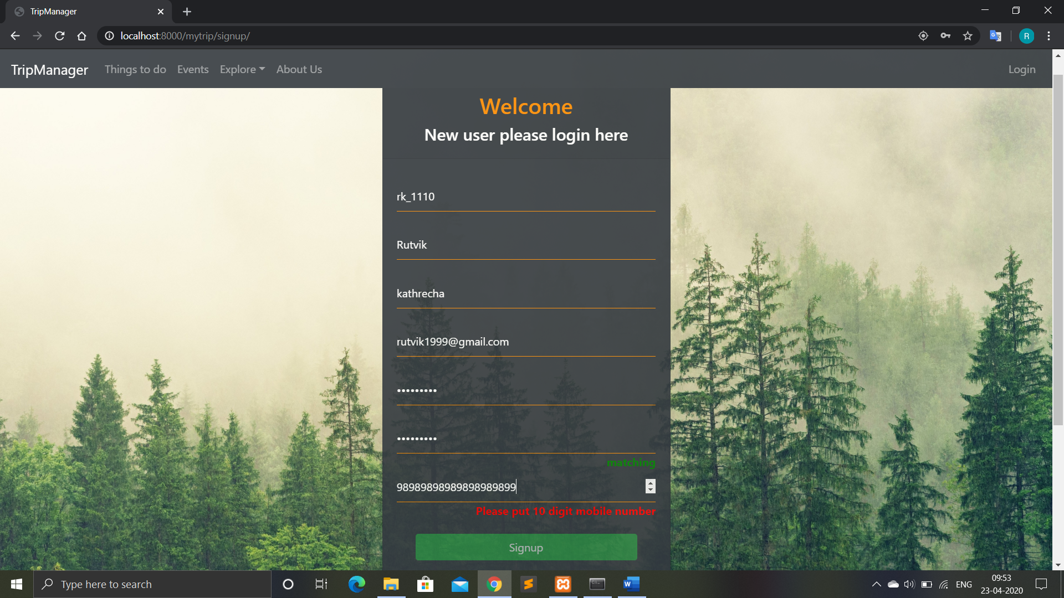

* When mobile no already in use

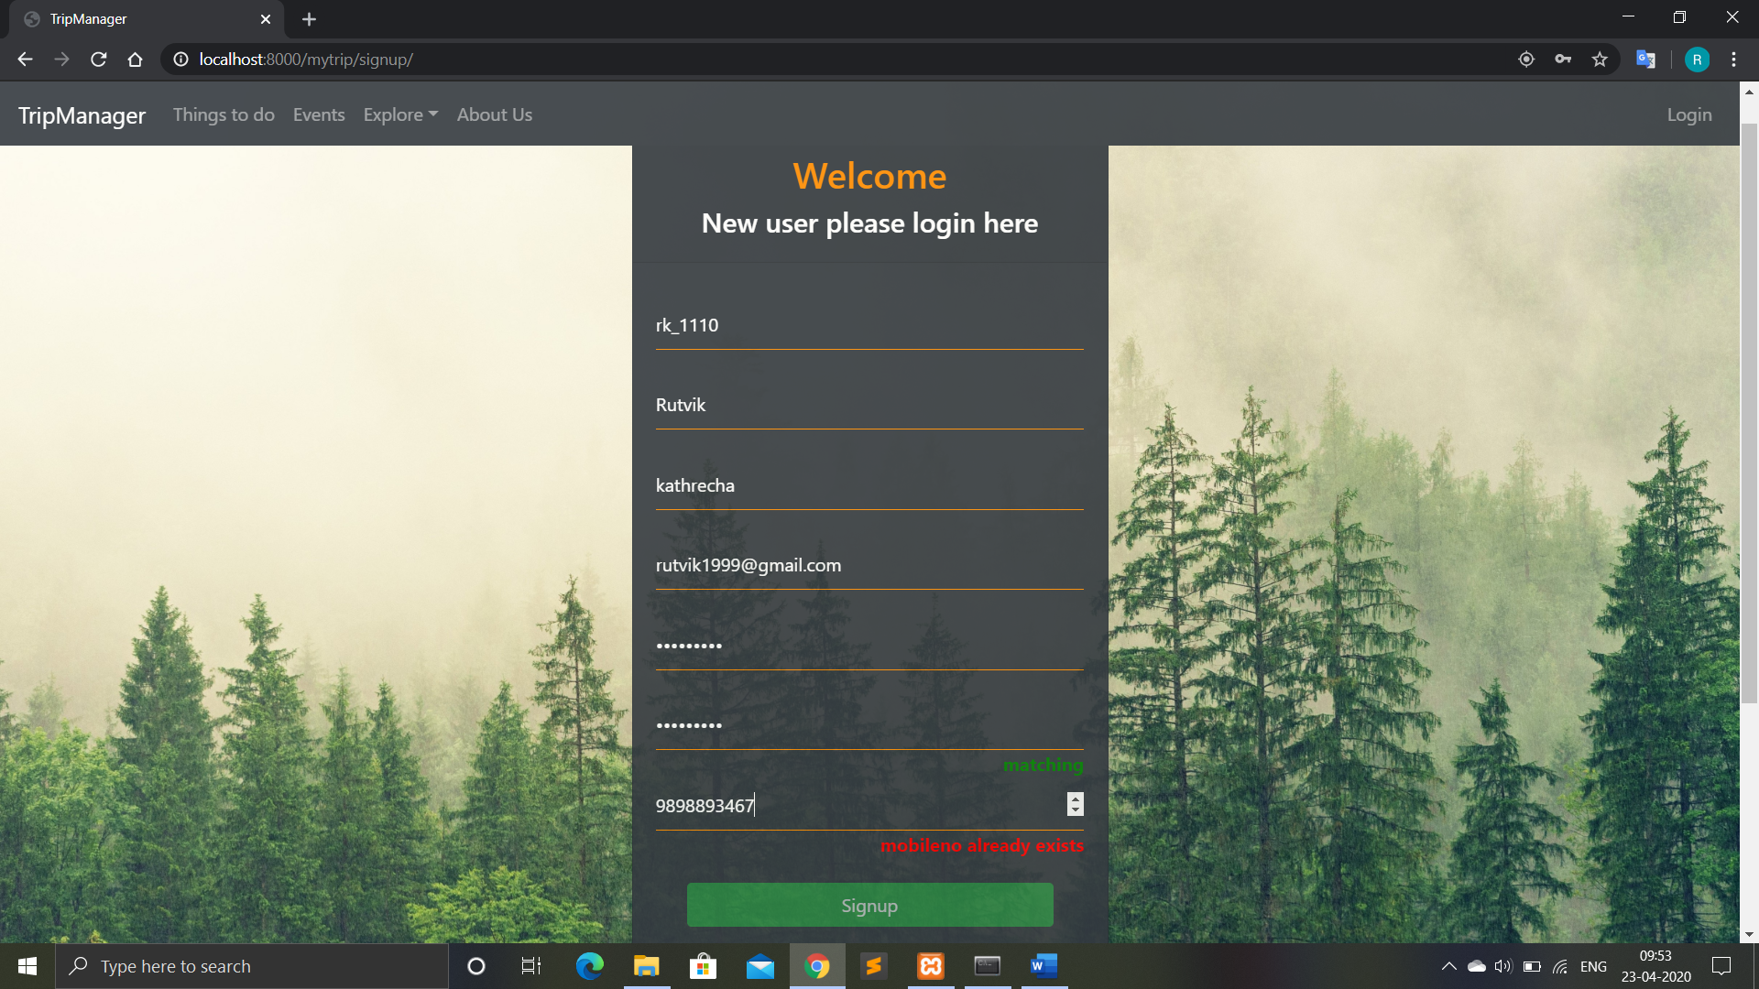

1. Event registration

Below is the snapshot of new event registration module.

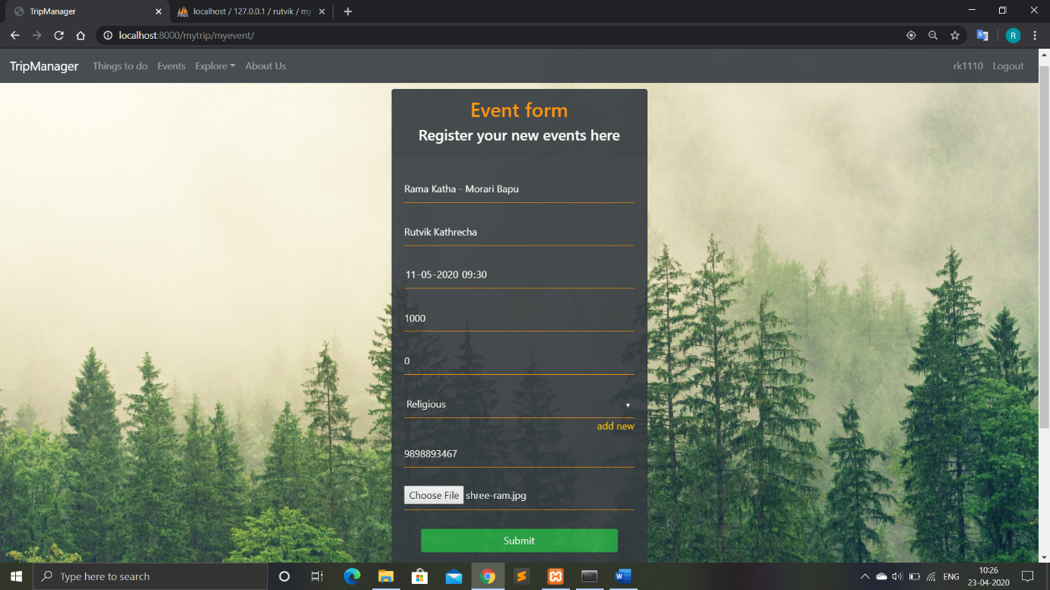

When user register their own event, event name must be unique. If the new event has the same event name as other already registered event then error message will be shown.

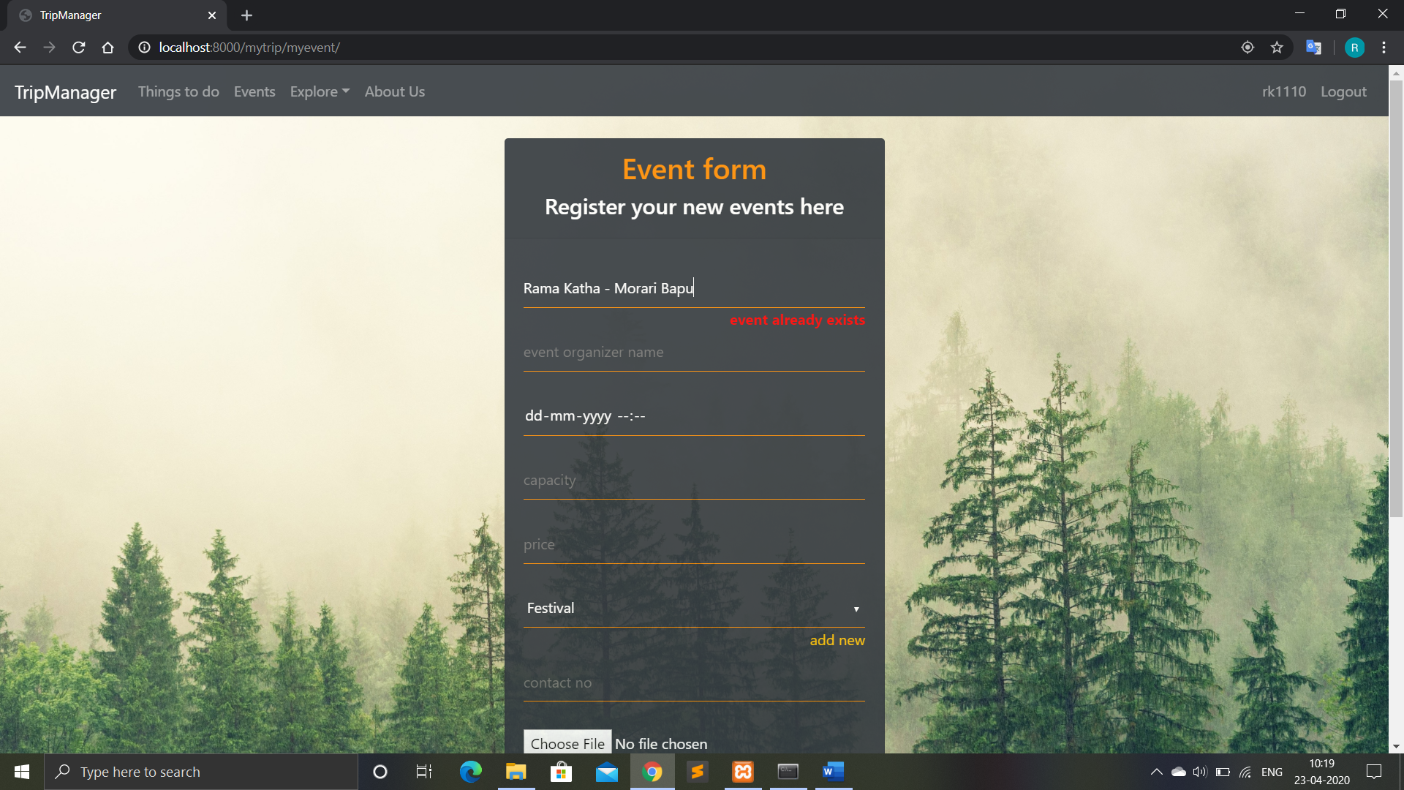

# Screen-shots

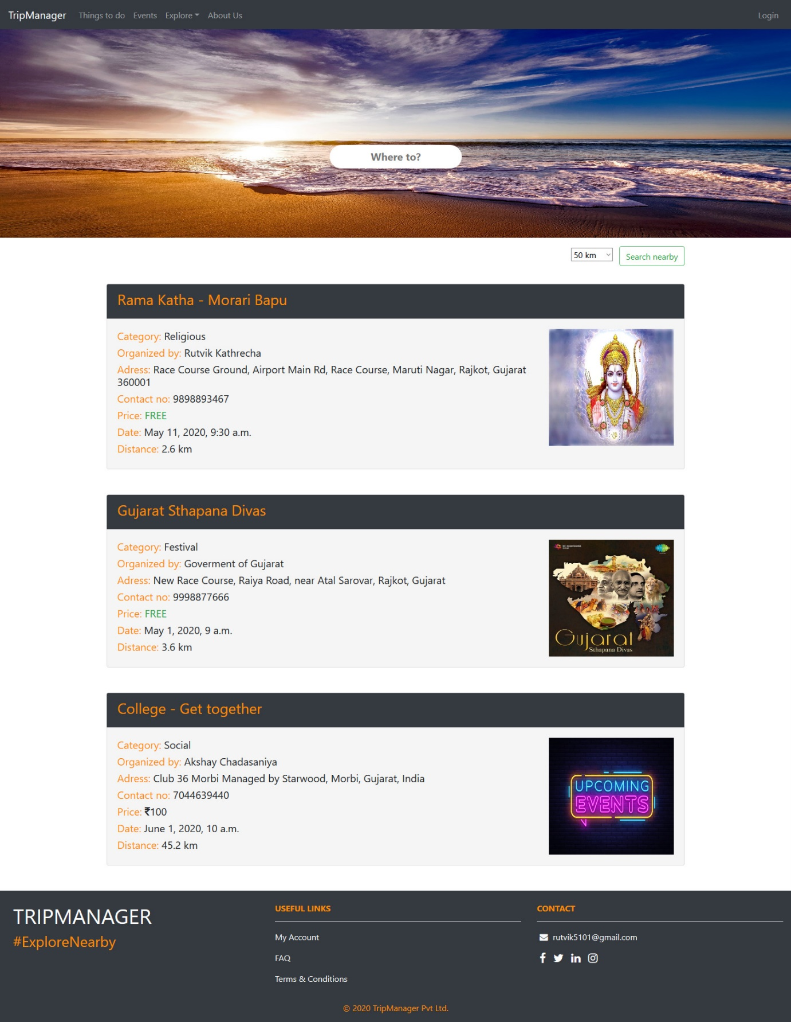

Home Page

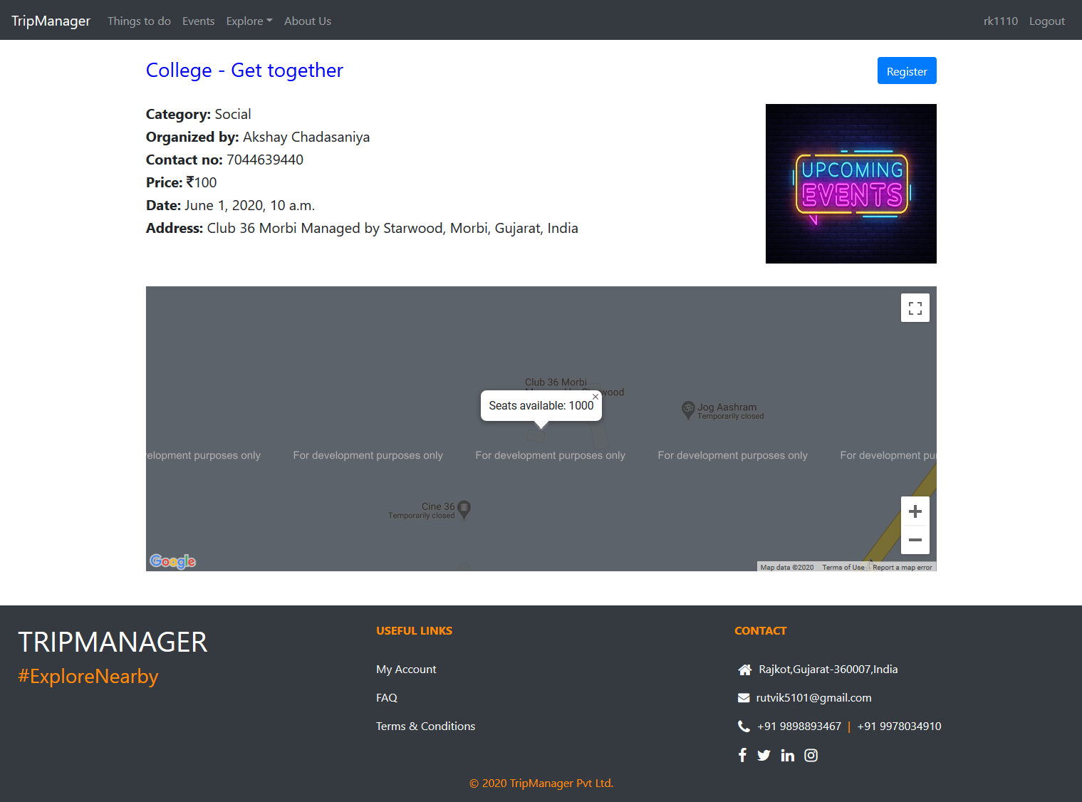Event Details page

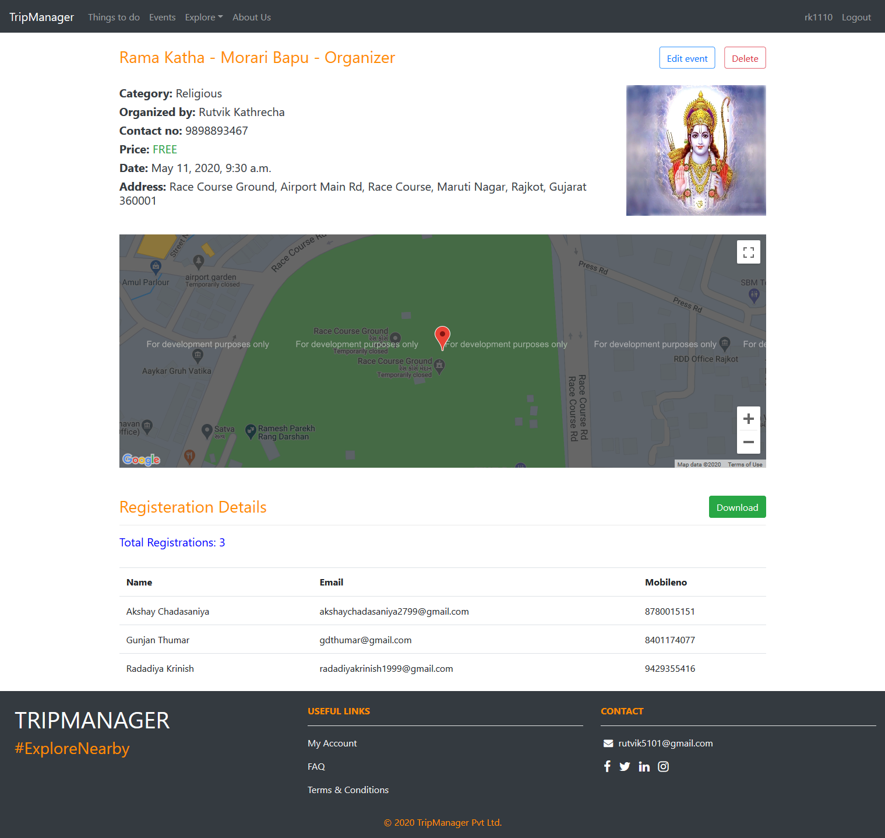

Event Details page - Organizer

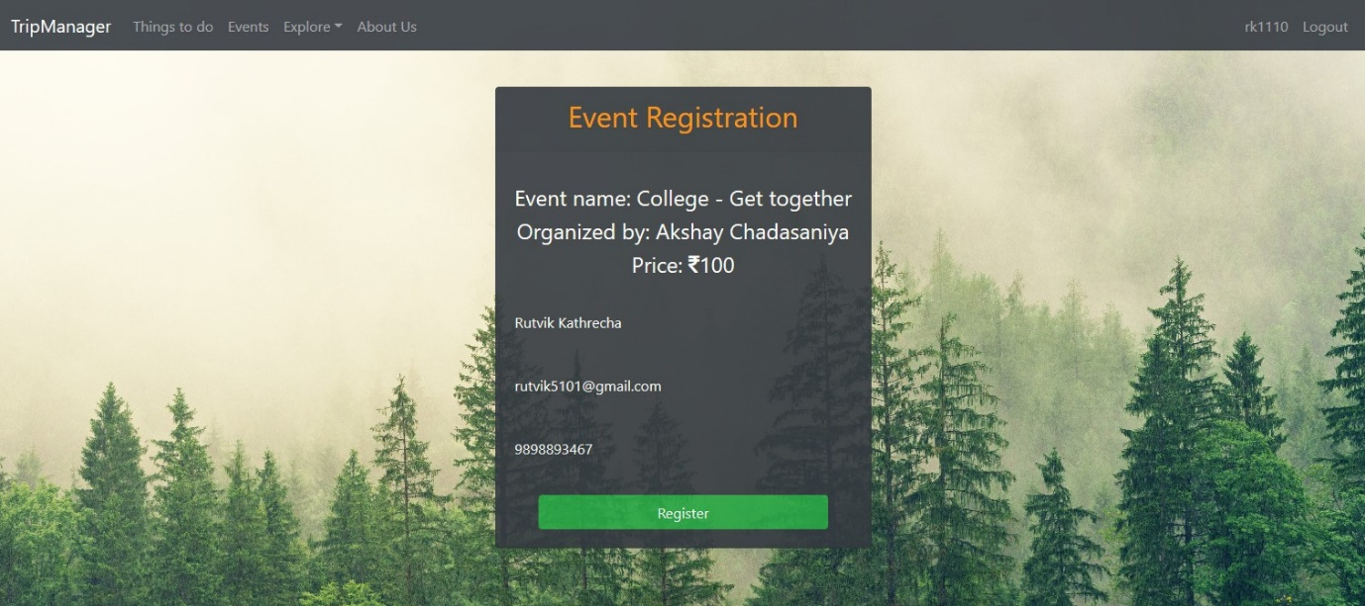

Event Registration form

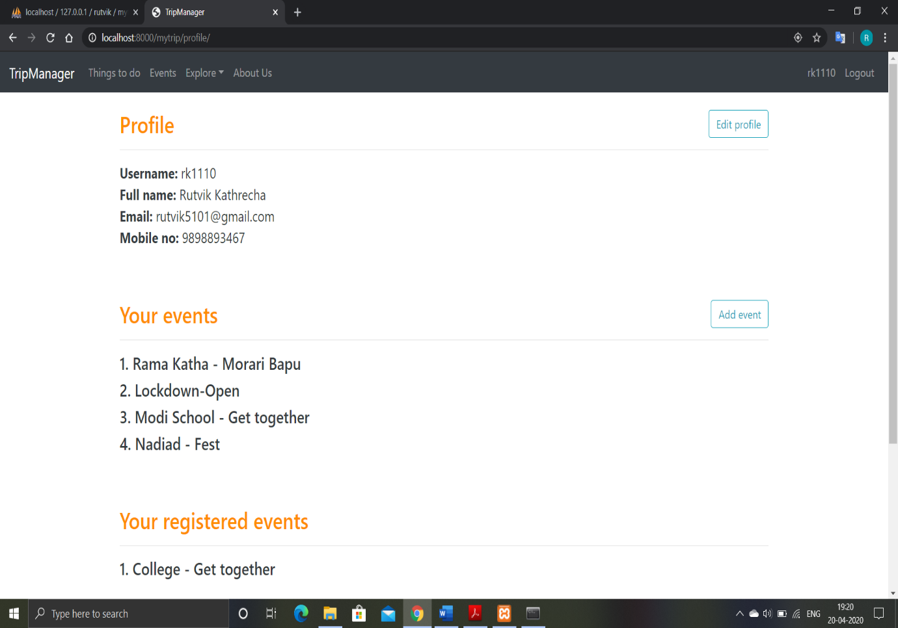

Profile Page

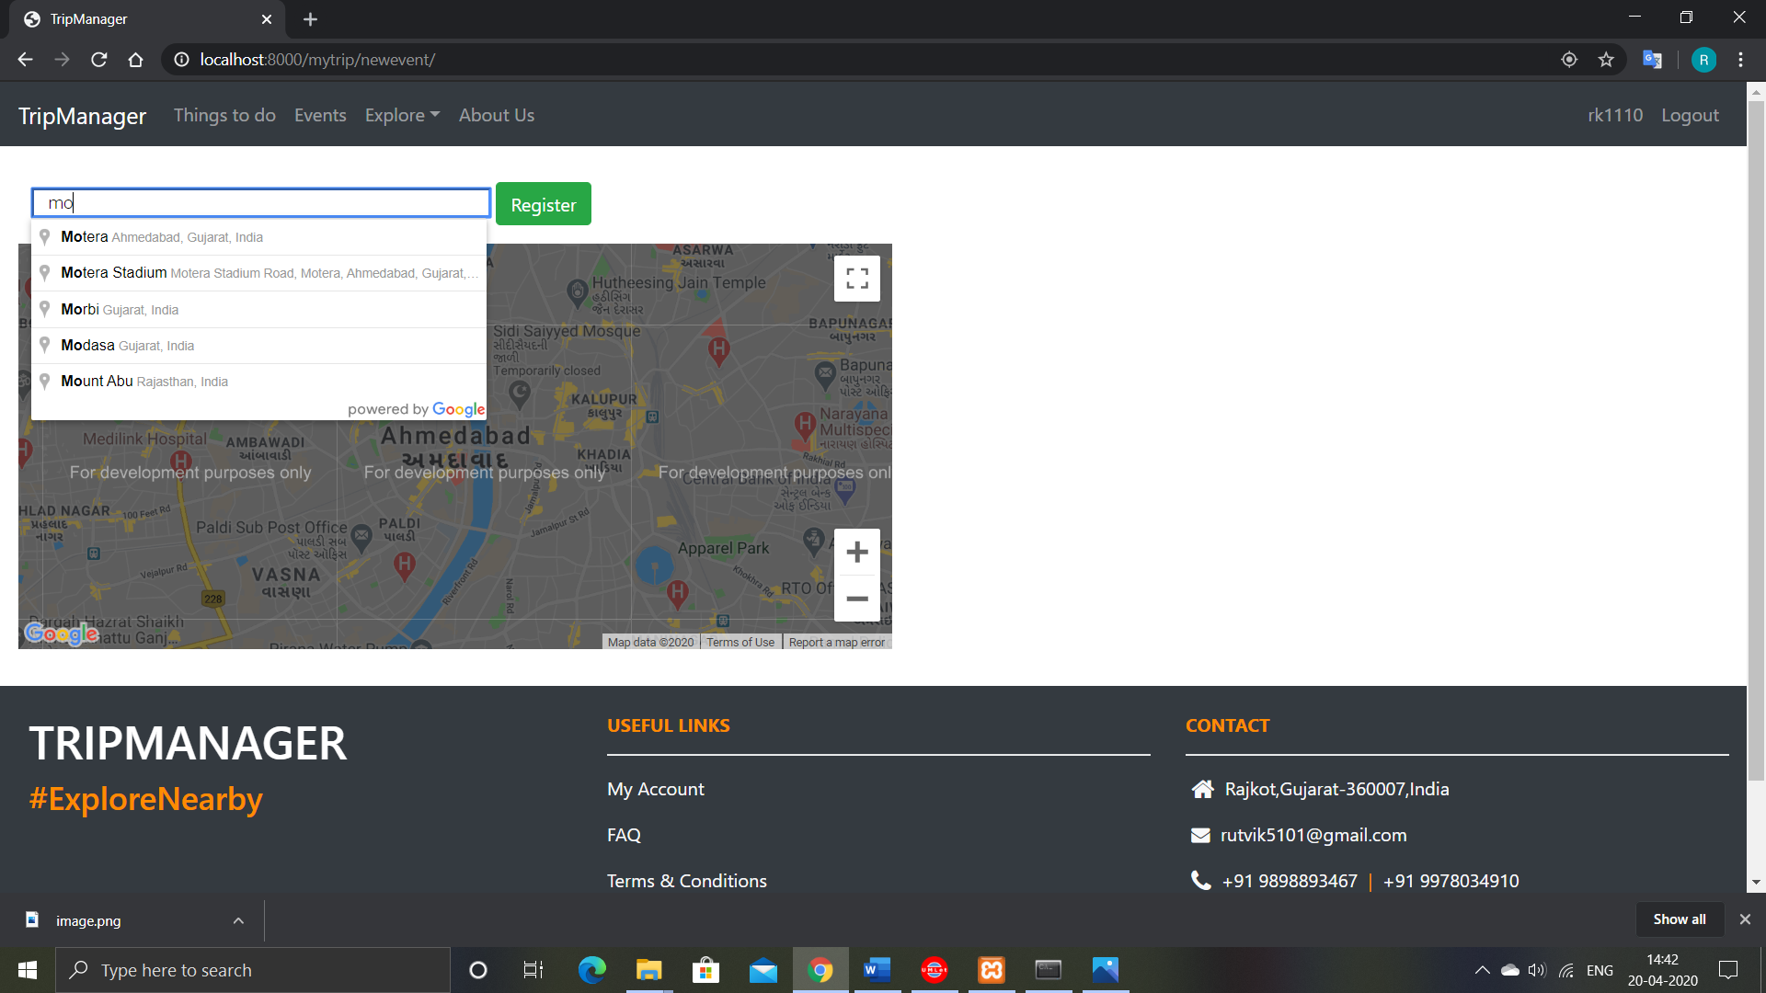

These two are the screen-shots of the address pickup for adding new events. As the user start writing address, the API will give the suggestions regarding the address. And as the user pickups the appropriate place, a marker will be placed at that place suggesting the selected place. Both the scenarios are illustrated in the given screen-shots respectively.

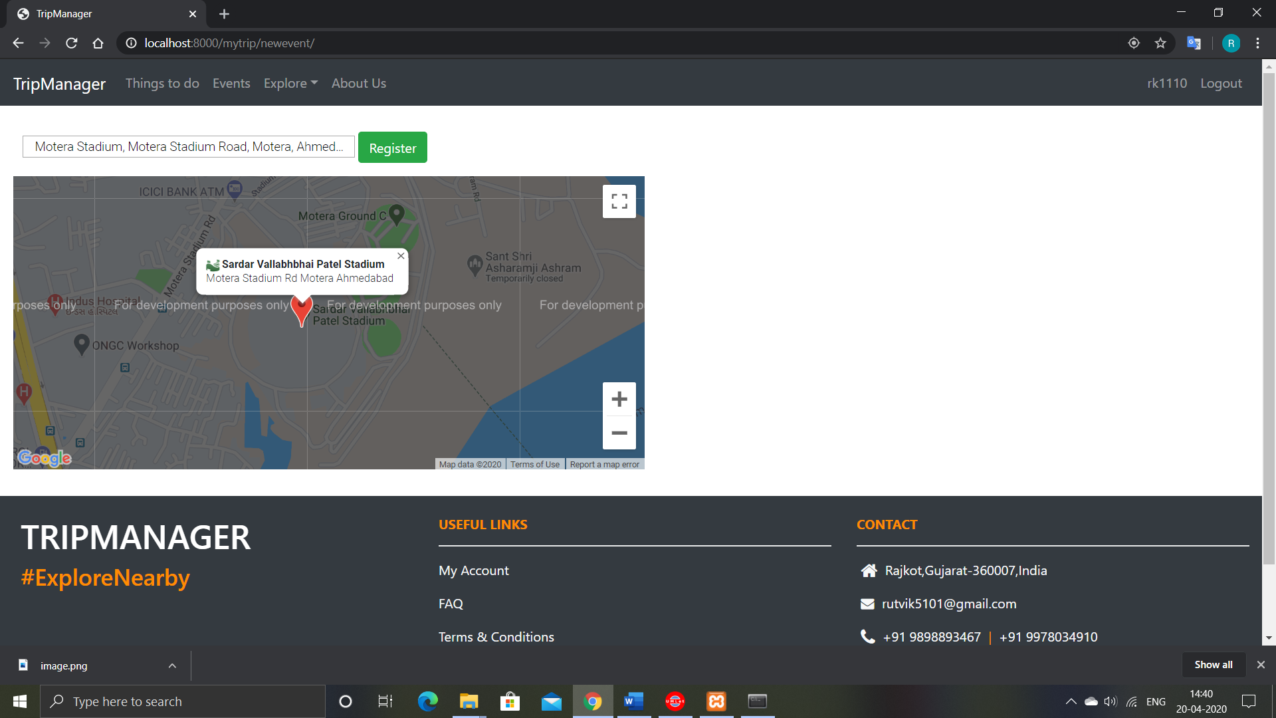

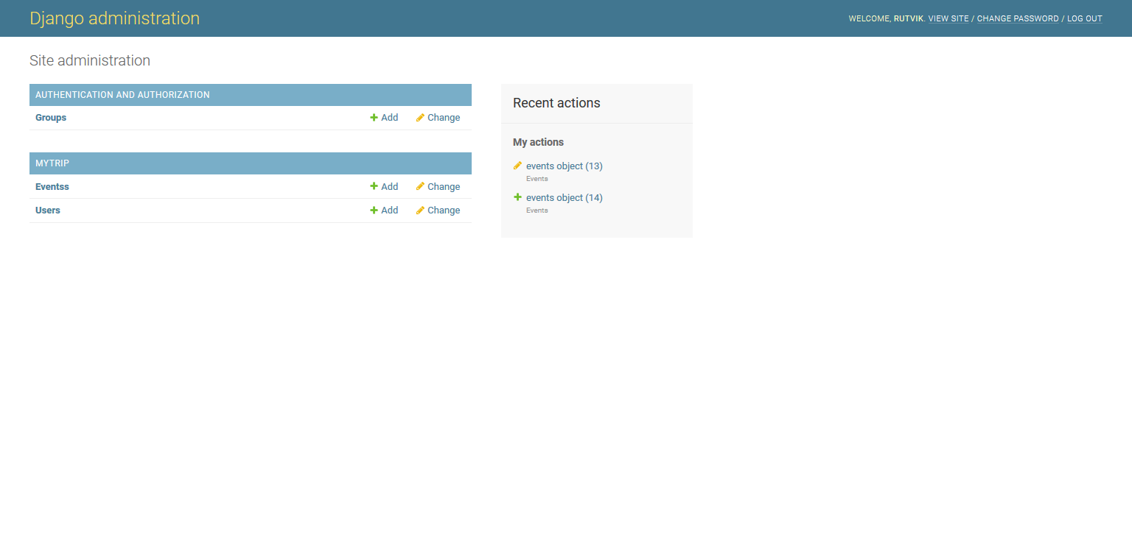Administrator Page

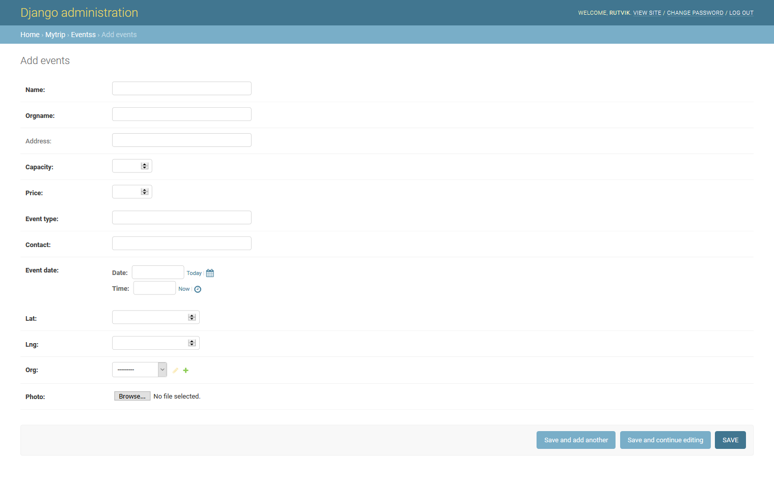

Event entering page for Admin

# Conclusion

In this project we have successfully built the nearby event functionality. Which provides results based on user’s location. Other services like using google maps API and functionalities like signup/login, events, and admin side are all created successfully with all test cases checked. All the designing part is also done successfully by using CSS, Bootstrap and JavaScript.

# Limitation and Future Extension

Limitations

We have not used the paid version of google map API which includes more support for various services. We have not implemented the payment module required in the process of registering for an event. Currently the scope of the project is small.

Future Extension

* To support nearby places and hotels.
* To support payment module in the event registration process.
* To support user login via third parties.
* To deploy the project on the web.

# Bibliography

* <https://docs.djangoproject.com/en/3.0/>
* <https://developers.google.com/maps/documentation>
* <https://console.cloud.google.com>
* <https://stackoverflow.com/>
* <https://www.geeksforgeeks.org/>
* <https://www.w3schools.com/>
* <https://www.wikipedia.org/>
* <https://www.google.com/maps>